Summary of Survey
Alumni major in 503 (2017)

104 answers

Summarys
- Name:
- Courses and phone numbers/email:
- Year graduated:
- Gender:

Male
Female
- Type of graduation:
Excellent
Very good
Good
Average good
Ordinary
- Employment status:

Employment
Unemployment
- Average income per month:
- Workplace:
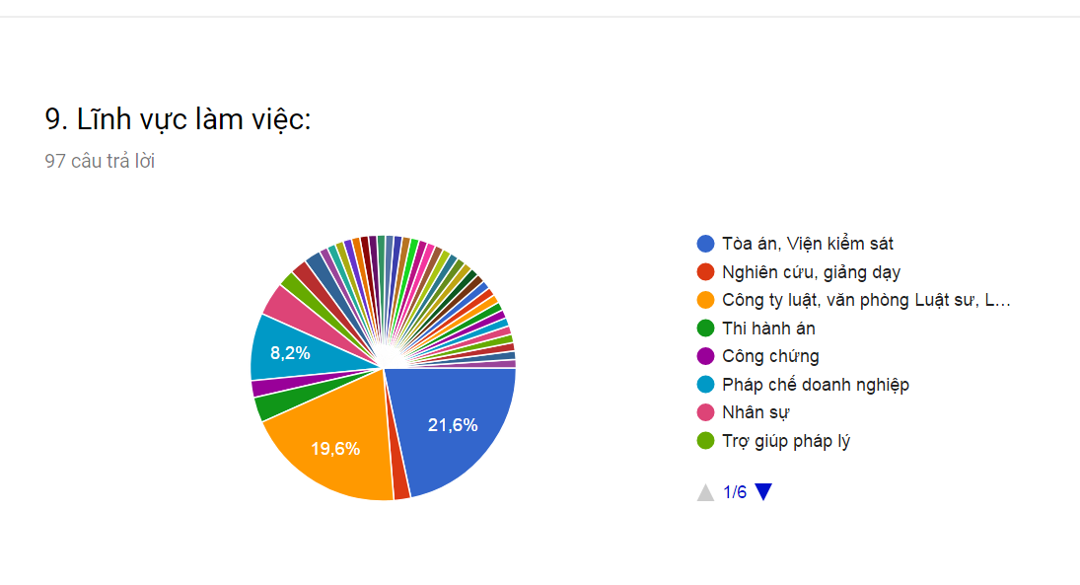
- Field of work:
Court, procuracy
Researcher, lecturer
Law company, Law offices .
Judgment execution
Notarizing
Business laws
Human resources
Legal aid

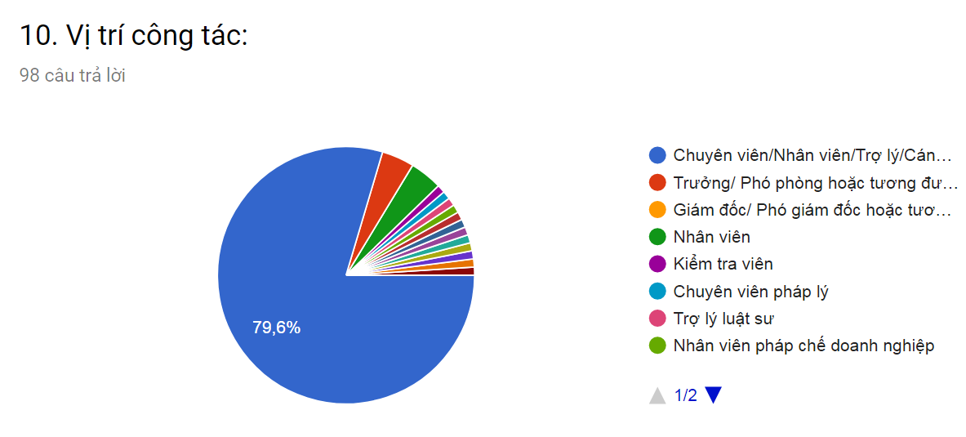
- Work Position:

Professional, employee , assistant

Head of the department / Deputy of the department

Director/ Vice Director

Employee

Inspector

Legal professional

Lawyer assistant

Legal staff in enterprises

11. Sau tốt nghiệp bao lâu Anh /chị có việc làm đầu tiên? (không kể việc làm thêm khi đang đi học): 99 câu trả lời

How long have you got the first job since graduated ?(exclude the part-time jobs when you was studying ): 99 answers

Have jobs after graduation

1 – 3 months

3 -6 months

6 – 12 months

1 – 2 years

Don't get the jobs , continue studying to become masters student

Unemployment

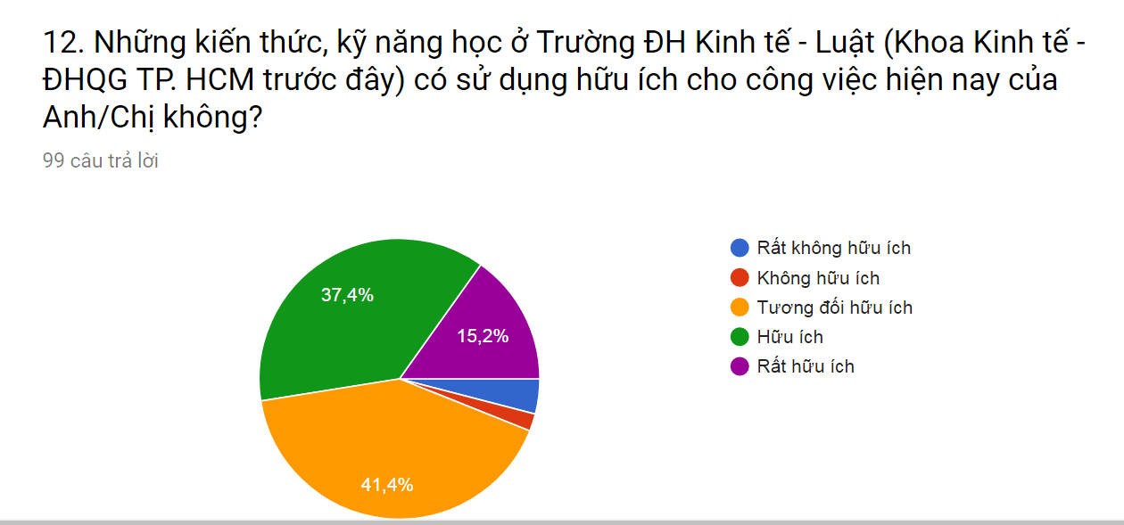
Ghi chú: Rất không hữu ích: 4% - Không hữu ích: 2%

Is the knowledges and skills you have learnt in University of Economics and Laws (Faculty of Economics – HCM National University in the past ) useful for the your current jobs ?
Very not useful
Not useful
Pretty useful
Useful
Very useful
Note : very useful - not useful .

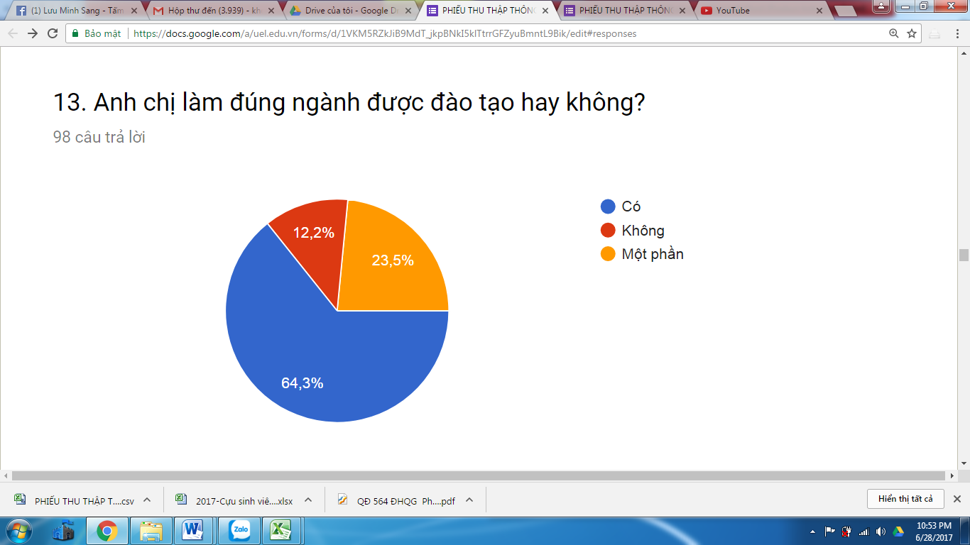

Did the job relate to your majors?

Yes

No

A little related

PART II. COURSE EVALUATION: Show average scores only

The course syllabus(courses) has clear objectives [Objectives, curricula contents]: 3.82

The curriculum aims to meet social requirements [Objectives, curricula contents]: 3.78

Curriculum update [Objectives, curricula contents]: 3.76

The curriculum has a good combination of basic knowledge, specialization and professional skills [Objectives, curricula contents]: 3.19

Highly practical curriculum [Objectives, curricula contents]: 3.13

The course provides a good background in the majors [Results obtained from the training program (course)]]: 3.95

The course provides good specialized knowledge [Results received from the training program (course)]: 3.74

The course develops the skills necessary for the jobs [Results obtained from the training program (course)]: 3.28

The course gives you confidence about your ability to meet the requirements jobs[Results of the training program (course)]: 3.37

The course will help you develop morals, personality [Results received from the training program (course)]: 3.95

Course to help employers appreciate you / your [Results received from training program (course)]: 3.50

The Course help employers with appreciating you / your [Results received from training program (course)]: 3.50

There is a reputation [Feeling about the School]: 3.90

Prestigious training [Feeling about the School]: 3.90

Prestigious scientific research [Feeling about the University]: 3.65

Have a close relationship with business, employers [Feelings about the School]: 3.43

Have a good relationship with alumni [Feeling about the School]: 3.51

